System Architecture (SA)

Objectives:
The server is responsible for interacting with web and client side, calling algorithm modules and storing diagnosis data. When the server receives a log-in request, it checks the validity of the input information and evaluate the identity of visitor. The user may also upload X-ray spine images for scoliosis detection. In that case, the server calls the corresponding scoliosis detection module, and the result will be recorded before it is sent to the user interface.
After implementation, the system should be able to calculate the Cobb Angle with high accuracy given any X-ray spine image with a fixed resolution and image format.

Core Functionality:
- Data storage:
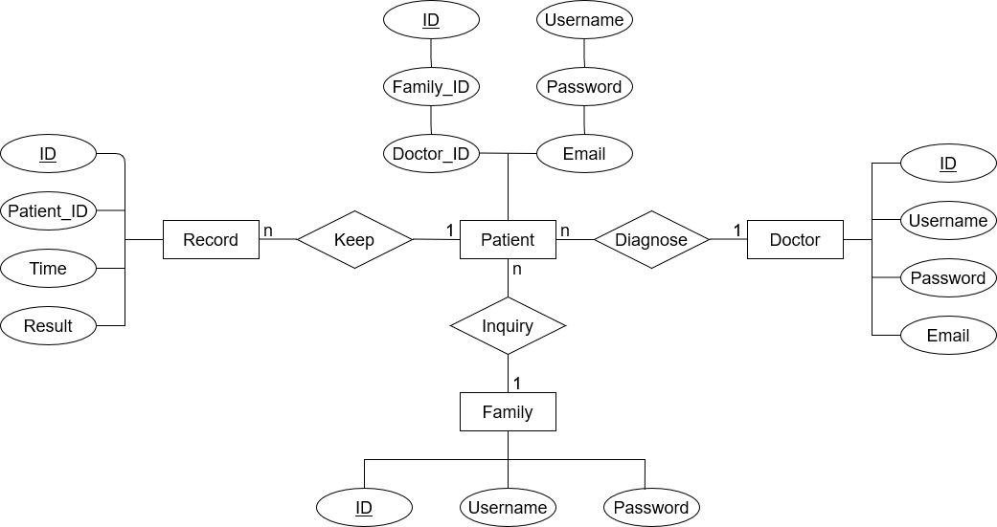

As is shown in the Entity Relationship Diagram, there will be mainly 4 Tables stored in the server’s database. Users’ personal information is stored in Patient, Family and Doctor Table respectively, and all the diagnosis history is saved in the Record Table.
In this work, we assume that each doctor/family is related with one or more patients, while each patient will have one or more diagnosis records. Therefore, Record and Patient Table should keep the foreign key of Patient and Doctor/Family Table respectively.

- Cobb Angle Calculation:

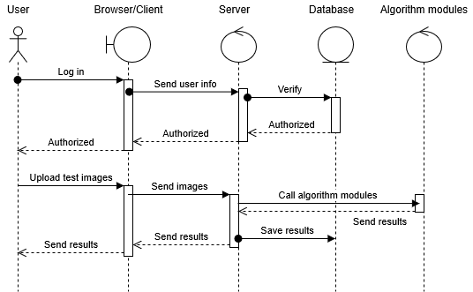
The end users (could be patients, doctors or family members) need to log in before uploading their test images. After the verification of username and password, the image is uploaded, and then passed to the server.
The server calls Scoliosis Detection Modules for the Cobb angle calculation. The calculation results are then sent back to the user interface. The server is also responsible for saving the results to the patient’s diagnosis records.

System Design and Requirements:
The server development process is mainly based on Java framework and MySQL database, so an updated version of Java is required to use the application. In addition, operating systems without graphic user interfaces (GUIs) are not supported, since all the interactions are based on a GUI. We are using conventional Hypertext Transfer Protocol (HTTP) to provide web services, so users need to be connected to the Internet beforehand.
Recommended settings:
Windows 10
Windows 8.x
Ubuntu Linux 15.10 (8u65 and above)
Ubuntu Linux 14.x (8u25 and above)
RAM: 128 MB
Disk space: 124 MB for JRE; 2 MB for Java Update
Processor: Minimum Pentium 2 266 MHz processor

Expected Functional Extensions:
- Lanke classification
- Scoliosis prediction on the basis of previous record of the patient.
- Providing suggestions and instructions for the family member according to the newest diagnosis results.

